UNDERGRADUATE FINAL YEAR REPORT

Department of Computer Science and Information Technology NED University of Engineering and Technology




Blockchain-Based Smart Platform for Connecting Innovative Ventures and Industries

Group Number: CT-21008 | Batch: 2021
Group Member Names:
Muhammad Owais Ansari Muhammad Sulman Sarwar Sheikh Abdul Basit  Asad Ullah |  | CT-21069 CT-21071 CT-21084 CT-21089

Approved By
. . . . . . . . . . . . . . . . . . . . . . . . . . . . . . . . . . . . . . . . . . . . . . . . . . . . . . . . . . . . . . . . . . . . . . . . . . . . . . . . . . . . . .
Dr. Najeed Ahmed Khan Professor, CS & IT - Project Advisor
Ms. Samia Masood Awan Lecturer, CS & IT– Project Co-Advisor

© NED University of Engineering & Technology. All Rights Reserved – June 2025

Author’s Declaration
We declare that we are the sole authors of this project. It is the actual copy of the project that our advisor(s) accepted, including any necessary revisions. We also grant NED University of Engineering and Technology permission to reproduce and distribute electronic or paper copies of this project.

Muhammad Owais Ansari Muhammad Sulman Sarwar
CT-069 CT-071
ansari4406249@cloud.neduet.edu.pk sarwar4406678@cloud.neduet.edu.pk

Sheikh Abdul Basit Asad Ullah
CT-084 CT-089
basit4402242@cloud.neduet.edu.pk ullah4406732@cloud.neduet.edu.pk

Statement of Contributions
Owais Ansari: In the final year project at NED University, Owais Ansari played a crucial role in implementing prototypes for the platform to aid in the project’s design process. He worked on the front-end development part of the FYDP focused solely on Investor and Admin Panel Dashboard and their API integration, ensuring they were user-friendly and visually appealing which would establish a deliberate tone for what was to be a clean, functional user experience.

Sulman Sarwar: He has been actively involved in the project, Salman created a substantial impact, primarily revolving around backend development of the FYDP using NEST.JS and establishing the project’s foundational capabilities. He has precisely completed comprehensive documentation of the API, played a crucial role in collecting and preparing the data for the Investor and Startup, He had also been involved the plan of implementation of Blockchain technology maintaining security and transparency.

Sheikh Abdul Basit: Basit focused on building the foundation of the platform’s AI-powered matching system. He was actively seeking which technologies of AI can be used more effec- tively in the FYDP. He designed the framework to match investors with startups effectively, making sure the system is both accurate and helpful. He also worked on flask API, His efforts laid a strong groundwork for this crucial feature.

Asad Ullah: He has been active since the start of the project, contributing to the planning and development of the FYDP, played an extremely important role in organizing and instructing the project, and helping all of the team members to work together effectively. He contributed in implementing the integration of Startup and Admin Dashboards and their APIs so that the frontend is connected to the backend. And also worked on around making transactions secure and transparent using blockchain.

All authors contributed equally to write the final year project report.

Contents

List of Abbreviations ix
Similarity Index Report xi
- Introduction 1
  - Background Information 1
  - Problem Statement 2
  - Significance and Motivation 3
    - Democratizing Investment Opportunities 3
    - Empowering Startups and FYDPs 3
    - Ensuring Accountability through Milestone-Based Funding 3
    - Reducing Costs and Simplifying Investment Processes 4
    - Promoting Growth, Innovation, and Economic Impact 4
  - Methodology 4
    - Requirement Analysis 7
    - System Design 7
    - Development Tools 9
    - Implementation Phases 11
    - Deployment and Feedback 12
  - Report Outline 12
    - Chapter 1: Introduction 12
    - Chapter 2: Literature Review 13
    - Chapter 3: Requirement Specification & Analysis 13
    - Chapter 4: System Design and Implementation 14
    - Chapter 5: Testing and Quality Assurance 14
    - Chapter 6: Results and Discussion 15
    - Chapter 7: Future Enhancements 15
    - Chapter 8: Conclusion 15
- Literature Review 17
  - Introduction 17
  - Review of Related Systems 17
  - Existing Platforms (e.g., AngelList, Kickstarter) 18
  - Blockchain in Investment Platforms 18
  - Smart Contracts 18
  - AI in Investor-Startup Matching 21
  - AI Models for Matching and Analysis 21
  - Case Studies: Successful AI-Driven Investment Matches 23
  - Summary 23
- Requirement Specification & Analysis 24
  - Introduction 24
  - Functional Requirements 24
  - Non-Functional Requirements 25
  - Flow Diagram 25
  - Technology Stack Used 27
    - Front End 27
    - Back End 27
  - Use Case Diagram 27
  - ERD of our database system 30
  - Activity Diagram 33
  - Chapter Summary 35
- System Design and Implementation 36
  - Introduction 36
  - Platform Features and Functionalities 36
    - Blockchain-Based Investment System 36
    - AI-Powered Matching Algorithm 36
    - Decentralized Governance (DAO) 37
    - Smart Contract Automation 37
  - Architectural Design 37
    - Frontend Layer 37
    - Backend Layer 38
    - Blockchain Layer 39
    - AI Layer 39
    - Database Layer 40
  - Frontend Design and User Interface (UI/UX) 40
    - Admin Dashboard 40
    - Investor Dashboard 41
    - Startup Dashboard 42
    - Matching System 42
  - Backend Design and Integration 43
  - Security and Compliance Framework 43
  - Chapter Summary 44
- Testing and Quality Assurance 45
  - Introduction 45
  - Testing Strategy and Methodology 45
  - Unit Testing 46
    - Frontend Unit Testing 47
    - Backend Unit Testing 47
    - Smart Contract Unit Testing 47
  - Integration Testing 48
    - Backend API Integration 48
    - Smart Contract Integration 48
  - System Testing 49
    - Functional Testing 49
    - End-to-End (E2E) Testing 49
    - Cross-Browser Testing 49
    - Responsiveness Testing 49
  - Performance Testing 50
    - Load Testing 50
    - Stress Testing 50
  - Security Testing 50
    - Smart Contract Security Testing 51
    - Web Application Security Testing 51
  - Bug Tracking and Issue Resolution 51
  - Testing Tools Used 52
  - Test Results and Evaluation 52
  - Chapter Summary 53
- Results and Discussion 54
  - Overview of Results 54
  - Comparison with Existing Systems 54
    - Web2 vs Web3 Architecture 54
    - AI-Powered Matching vs Traditional Filtering 56
  - Performance Evaluation 56
    - AI/NLP-Based Investor-Startup Matching Evaluation 56
  - Challenges and Limitations 57
  - User Feedback 58
  - Chapter Summary 58
- Future Enhancements 60
  - Introduction 60
  - Planned Technical Improvements 60
    - Enhanced Platform Security 60
    - AI-Driven Startup and FYDP Evaluation 61
  - Feature Expansion and Scalability 61
    - Smart Contract Enhancements 61
    - DAO-Based Governance 62
    - Cross-Platform and Multi-Chain Integration 63
  - Wider Applications and Compliance Considerations 63
    - Regulatory Compliance and IP Policy 63
    - Expansion to Broader Use Cases 63
    - Localization and Inclusion 64
  - Chapter Summary 64
- Conclusion 65
  - Summary of Contributions 65
  - Lessons Learned 65
  - Project Impact and Final Reflections 66

List of Figures

  - SDLC Diagram 6
  - Architectural Diagram 8
  - Interaction between Startups, Investors, Blockchain, and Smart Contracts 20
  - Bi-Encoder Architecture for Sentence-BERT 22
  - Sentence Embedding Equation 22
  - Flow Diagram 26
  - Use Case Diagram 29
  - ERD Diagram 32
  - Activity Diagram 34
  - Landing Page 38
  - Swagger for APIs 39
  - Admin Dashboard 41
  - Investor Dashboard 41
  - Startup Dashboard 42
  - Investor matchmaking using AI 43
  - Testing Phases 46
  - Correlation Of unit, integration and system testing 48
  - bug reporting process 51
  - Web2 vs Web3 Architecture 55

List of Tables
  - Functional Requirements 24
  - Non-Functional Requirements 25
  - Comparison of AI-Powered Matching vs Traditional Filtering 55
  - Comparison of AI-Powered Matching vs Traditional Filtering 56
  - Feature Matrix comparing AngelList, Kickstarter, and InnoVenture 57
  - Model Overview 57
  - Smart Contract Enhancement Comparison 62

List of Abbreviations
FYDP Final Year Design Project AI Artificial Intelligence
Web3 Third Generation of the World Wide Web (Decentralized Web) DAO Decentralized Autonomous Organization
DApp Decentralized Application
API Application Programming Interface SDG Sustainable Development Goal SDLC Software Development Life Cycle

United Nations Sustainable Development Goals
The Sustainable Development Goals (SDGs) are the blueprint to achieve a better and more sustainable future for all. They address the global challenges we face, including poverty, in- equality, climate change, environmental degradation, peace and justice. There is a total of 17 SDGs as mentioned below. Check the appropriate SDGs related to the project.
- No Poverty
- Good Health and Well-Being
- Gender Equality
- Affordable and Clean Energy
- Industry, Innovations and Infrastructure
- Sustainable Cities and Communities
- Climate action
- Life on Land
- Partnership for the goals
- Zero Hunger
- Quality Education
- Clean water and Sanitation
- Decent Work and Economic growth
- Reduced Inequalities
- Responsible Consumption and Production
- Life Below Water
- Peace, Justice and Strong Institution

Similarity Index Report
The following students have compiled the final year report on the topic given below for partial fulfillment of the requirement for bachelor’s degree in Computer Science.

Project Title: Chain-Based Smart Platform for Connecting Innovative Ventures and Industries

S. No. Student Name
- Muhammad Owais Ansari
- Muhammad Sulman Sarwar
- Sheikh Abdul Basit
- Asad Ullah

Seat Number
CT-21069 CT-21071 CT-21084 CT-21089

This is to certify that a plagiarism test was conducted on the complete report, and overall similarity index was found to be less than 20%, with maximum 5% from a single source, as required.

Signature and Date

Dr. Najeed Ahmed Khan
Professor, CS & IT – Project Advisor

[Plagiarism Test must be conducted on the project report by the project advisor using Turnitin Software, or any other software approved by the university. Project Advisor is required to sign the Plagiarism Certificate if the similarity is found as per rules defined in the guidelines.
Plagiarism reports must be included (only the first and last page) generated by Turnitin. A sample of the plagiarism test report is provided with the FYDP template package.]

© NED University of Engineering & Technology. All Rights Reserved – June 2025



Chapter 1
Introduction

Background Information
This project addresses the enduring inefficiencies and impediments that exist in the startup in- vestment ecosystem, which is central towards fostering technological development and creating jobs that in turn contributes to growth at the global level. Startups are expected to help change the world, however even the most promising ideas have trouble finding the capital needed to bring these ideas to fruition. Some of the key challenges that new ventures encounter include: insufficient access to a wide array of potential investors, fierce competition for visibility in a crowded marketplace, and trust eroded by security concerns.

Investors, especially the newcomers to the ecosystem, face challenges just as difficult. Most investment opportunities have high minimum investment limits which makes it impossible for most small or first time investors to invest, and there are no adequate mechanisms to measure the ventures which makes them work with partial information. In addition, there is a lack of disclosure and access to verifiable up-to-date data, which increases the risk that investors will make bad decisions. The gap in communication between investors and the startups leaves a void in the ecosystem that hampers innovation and growth, therefore creating an opportunity for a proper structure in order to plug the gap is long overdue.

Outside the boundaries of the Startup world, the Final Year Design Projects (FYDPs) provide yet another opportunity and challenge. These projects, usually pitched by students of tertiary institutions, often develop unique solutions to serious issues in the society. Nevertheless, most of these FYDPs do not see the light of the day because they are unable to grow out of the academic setting due to lack of money and exposure or platforms to demonstrate what they can do. They contain a huge amount of undisclosed potential that, if properly nurtured, could result in exceptional breakthrough organizations capable of solving various global issues.

In order to tackle these problems in a more holistic way, THIS project utilizes the disruptive potential of Blockchain technology and artificial intelligence (AI). With blockchain technology, performing transactions becomes secure, decentralized, and tamper-proof. This allows every participant to be able to trust each other because everybody is accountable and transparent. AI, on the other hand, adds value by providing actionable insights and all the benefits of predic- tive analytics that equips both startups and investors with the necessary tools to lower risks. By bringing these innovative and state-of-the-art technologies together, This project seeks to deliver a new kind of platform that promotes and benefit startups, investors and academic insti- tutions for economic growth centered on innovation.

Problem Statement
The systemic failures across the startup investment ecosystem prevent it from realizing its max- imum potential. These also barriers that further embatten them are lack of security trust, the unavailability of milestone based funding to maximize value, and poor visibility among in- vestors. The pillars trumpets of innovations Final Year Design Projects (FYDPs) are often developed but most of them don’t eventually become real business. This was due to deficient engagement with industrialists and weak affiliations within the ecosystem.

It also means that many smaller investors cannot participate owing to barriers like entry thresh- olds. Furthermore, due to the unavailability of clear and factual based instruments, such in- vestors cannot put reasonable determination to gauge the prospects of startups and FYDPs. As such, a higher degree of risk in investing is involved. These problems are made worse by Con- ventional investment platforms that are weak in accountability and security measures which more time than not leads to poor and ineffective exchanges.

This project aims to overcome these barriers through an integrated techno-driven based so- lution. The platform integrates the transparency and security of blockchain technology and AI-derived actionable insights, thus simplifying investment processes, democratizing access to opportunities and closing gap among startups, FYDPs, and investors. Driven by a desire for equal opportunity in the global co-founding environment, this revolutionary solution is cre- ated to maximize innovation potential and enable a more inclusive, efficient startup investment landscape.

Significance and Motivation

Democratizing Investment Opportunities
This project aims to tackle the inefficiencies present in startup investments by ushering in an era of a unified platform leveraging blockchain and artificial intelligence. This more accessi- ble platform democratizes investment, allowing smaller investors to get in on previously out- of-reach opportunities without the host of barriers that come with traditional methods. The platform equips users with tools and information which streamline their involvement in the investment process, even if they lack experience or capital, allowing them to interact easily with high-potential startups. As a result, this sort of inclusivity creates more different investors which continually brings the funding flow for startups and Final Year Design Projects (FYDP).

Empowering Startups and FYDPs
This platform is tailored to individual needs of startups and FYDPS (Find your development partner) such as visibility, funding and access to the industry. It addresses the limitation of a narrow market outreach by connecting them with a worldwide investor network. This also means direct scaling for startups and academic projects needing access to those resources who dream of turning innovative ideas into companies. Networking tools within the platform also allow for partnerships, mentorships and access to expertise that lets startups hone their strate- gies and evolve.

Ensuring Accountability through Milestone-Based Funding
By linking money to performance, a milestone-based funding mechanism creates accountabil- ity. Capital is deployed in tranches when startups accomplish set milestones, which mitigates the risk of misappropriation and makes sure that capital is effectively employed. This process is supported by blockchain technology, which ensures transparency and a secure transaction record that cannot be altered without the knowledge of all parties involved. Such funding strat- egy, not only increases investor confidence but also aligns the interests of both startups and investors thus promoting a sustainable and fair funding ecosystem.

It is worth mentioning that in the context of this article, academic projects especially the FYDPs

can be seen as unexploited sources of innovation. Such projects formulate innovative concepts in response to some challenges in the business world, but they do not really take off since there is neither the funding pressure nor publicity. This platform offers financing fosters such academic research with commercial potential by linking the students with the industry. Such projects, which are usually neglected, get the exposure they deserve and the platform transforms academic potential into real-life applications that solve challenges in the society.

Reducing Costs and Simplifying Investment Processes
In enhancing creativity, the platform also cuts down the cost of operations as it does away with middlemen thanks to the decentralized structure of the blockchain. This effectiveness enables faster and less costly AI-based analytics to be used by the start-ups, as well as their investors. Through simplifying the most complex processes, which are supported by engaging designs, the platform facilitates all stakeholders needing basic knowledge of investing and technology to be able to participate without struggles.

Promoting Growth, Innovation, and Economic Impact
This project in the end also contributes towards growth, innovation and economic impact. It draws attention to the created employee places, innovations and the overall development of the world’s economy through speeding up profitability of start-ups and academic projects. A number of funded projects will respond to some of the pressing global needs and thus provide answers for all the people. Through changes in the investing ecosystem, the project hopes to foster innovations, provide space for opportunities and allow great ideas to prosper in the future.

Methodology
The methodology employed in this project focuses on creating a user-centered, iterative plat- form that integrates cutting-edge blockchain and artificial intelligence (AI) technologies. By combining the benefits of decentralized, secure transactions with data-driven decision-making tools, the project aims to address inefficiencies within the startup investment ecosystem. This approach is designed to enhance transparency, accessibility, and scalability for all stakeholders,

including startups, investors, and academic institutions. One important tool for visualizing the development process is the SDLC (Software Development Life Cycle) diagram. The SDLC diagram helps define the flow of the project through various stages, such as planning, analysis, design, implementation, testing, and maintenance.

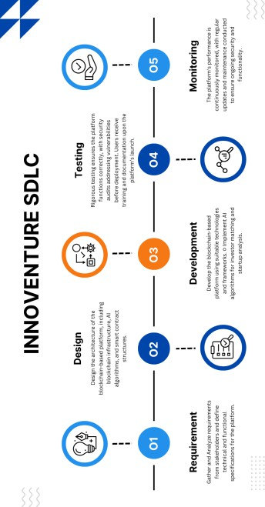

Figure 1.1. SDLC Diagram

Requirement Analysis
The methodology used in this project is centered on developing a user-oriented and iterative platform that utilizes state-of-art technologies like blockchain and artificial intelligence (AI). The project combines the advantages of securing properties and transactions through the use of a decentralized structure with data driven management in a bid to enable the startup investment ecosystem to be more efficient. Such approach seeks to improve transparent and cost-effective solutions which are both scalable and accessible to all participants, namely the startups, the investors and academic institutions. One such tool that can be essential in understanding the development life cycle is the SDLC (Software Development Life Cycle) diagram. The SDLC diagram is useful when once trying to understand the different ranks in which a project moves from its conception to maturity; these include planning, analysis, design, development, testing and eventually maintenance of the system.

The first methodology in this case is a requirement capturing and validation process that is aided by the participation of key stakeholder groups – the startups, their potential investors and academic partners. The approach of this phase is due to the focus of the project on market oriented problems and practical application of research outcomes, and thus it is necessary to look at how these aspects are addressed by the proposed platform. For most of the startups, it is primarily a matter of obtaining funds, ensuring a fairly high degree of focus on business, and finding suitable investors. Also, a high degree of transparency is sought by the investors, especially smaller first timers who also want the lower entry point.

System Design
System Design represents the structural components during the entire system’s development which focuses on a multi-layer architecture and ensures scalability, security and ease of use for all stakeholders. The design process is complemented by the Gantt chart which is a graphical illustration of the project schedule inclusive of the major tasks and the timelines for each spe- cific activity of the project. The Gantt chart assists the team members in monitoring the degree of advancement and estimating the time that may be required to accomplish certain phases and management of resources. Considering that the Gantt Chart is task-based, the construction of the system is possible as the task deployments is opportunities directed enabling completion of developments of the platform on target times.

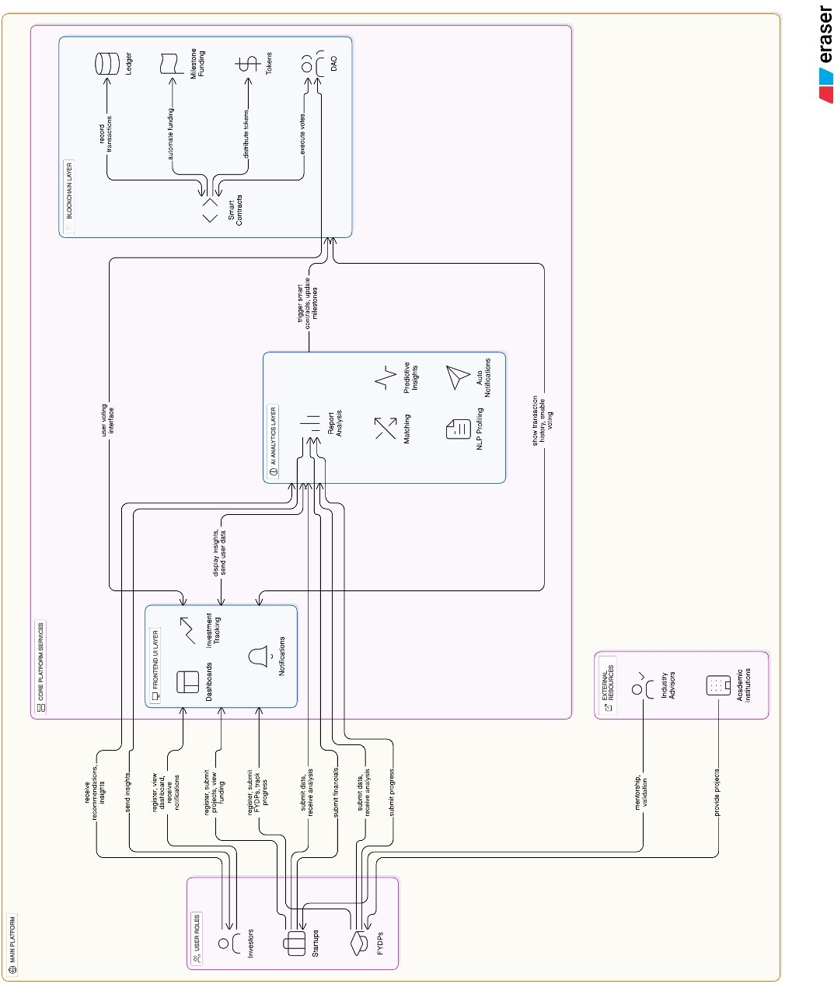

Figure 1.2. Architectural Diagram

Blockchain Layer

The ”Blockchain Layer” is the structural component of the entire system that is responsible for making secure transactions, controlling smart contracts and performing decentralized gov- ernance. All of these elements effectively ensure that any contributions or transaction and all decisions made are fixed forever and this in turn promotes the confidence people have in the system. Some examples include businesses receiving funds only when they reach a certain stage in their development and have entered into smart contracts that guarantee transactions. Having a blockchain, the funds’ owners do not need to engage intermediaries and the chances of persons attempting to cheat or abuse are minimized.

AI Layer

The AI Layer uses machine learning in complex ways for improved decision-making. Its mar- ket insights are useful for investors, while risk assessments are useful for start-ups. At the center of this layer is BERT, used in the analysis of unstructured data such as market news, and of company startup profiles and activity. By considering opinions and gathering informa- tion, one can build and comprehend a more sophisticated picture of the market. In addition, deeper word embedding techniques such as Word2Vec, GloVe are also utilized for numerical representation of text data, establishing semantic relationships of the data and enhancing the compatibility matching of startups and investors.
To support these capabilities, libraries such as NumPy and Pandas are leveraged for data manip- ulation and preprocessing. For instance, a multi-dimensional array can be very well managed by NumPy. However, they are especially beneficial when combined since Pandas allows for data cleaning and restructuring of the data for easier analysis. With the help of these tools and BERT, as well as other models, predictive analytics, startup and investor matching and trends are made and recommended which are meant for the specific stakeholder.

Development Tools

To bring the system to life, a variety of development tools and frameworks have been selected:

Blockchain Frameworks
      - Ethereum: A popular blockchain platform used for creating decentralized applications (dApps) and smart contracts. Ethereum provides the necessary security and scalability for managing transactions and funding.
      - Solidity: A programming language used to write smart contracts on the Ethereum blockchain.
Solidity is employed to develop automated, secure, and transparent contracts that govern the flow of funds and the execution of investment-related tasks.
      - Hardhat: A development framework that simplifies the process of testing, deploying, and debugging Ethereum smart contracts. Hardhat is used to deploy and manage smart contracts throughout the development lifecycle.

AI Libraries
      - TensorFlow: An open-source library for building predictive models, used for analyz- ing investment data, evaluating startup performance, and generating risk assessments. It supports advanced models like BERT for natural language processing.
      - NumPy and Pandas: Essential for data preprocessing, enabling efficient handling, clean- ing, and preparation of large datasets to support AI workflows.

Frontend Tools
      - React.js: A JavaScript library for building user interfaces, particularly single-page appli- cations. React.js is used to create dynamic, interactive user interfaces for the platform, allowing for smooth transitions and real-time updates.
      - Tailwind CSS: A utility-first CSS framework that enables rapid styling of web compo- nents.

Backend Tools
      - NestJS: The backend framework for the platform is NestJS, a progressive, TypeScript- based framework built on top of Node.js.

      - Express.js: A web application framework for Node.js that simplifies the creation of ro- bust backend services. Express.js is used to develop the RESTful APIs that interact with the front-end and backend systems.

Database
      - MongoDB: A NoSQL database that offers flexibility and scalability. MongoDB stores data related to users, projects, transactions, and AI models.

Implementation Phases
In order to provide successful integration of all the technologies and user interactions, this platform’s development process is planned to occur in a number of steps.

Prototype Development
The first prototype refers to a stage in which design and development is undertaken to achieve the purpose of demonstrating some specific capabilities of the platform. At this time, a proto- type is sent out to the stakeholders (start-ups, investors and academic institutions) so that their suggestions may be used for validation of the features within the core of the platform. This also assists in pinpointing concerns about the usability of the system before large scale development has commenced.

Smart Contract Implementation
Following the validation of the prototype, the next stage revolves around smart contracts to be developed and deployed on the Ethereum blockchain. These contracts control the funding release cycle, enable tracking and reporting of the milestones, and also some governance fea- tures. The smart contracts undergoes extensive testing for security and reliability to ensure they perform as desired when deployed in the actual environment.

AI Integration
The AI layer is implemented into the platform’s architecture to enable generation of insights and forecasts based on data. In this case, machine learning models are trained with past events

and some features that include startup-investor matchmaking and risk evaluation to be in place and evaluated for compatibility and relevancy.

Testing and Iteration
During the development process, the platform is subjected to a number of tests at every de- velopment phase. All functional tests are used to make sure all features are working as they should.

Deployment and Feedback
Once the platform is fully developed and tested, it will be deployed on cloud servers for scala- bility and reliability. The deployment process adds to configure necessary cloud infrastructure, managing high availability, and optimizing for performance. After deployment, the platform will be continuously monitored for any issues, and updates will be taken out regularly based on user feedback and new technological advancements.

Report Outline
This report provides a structured overview of the project, detailing its goals, methodologies, and outcomes across eight chapters. The project is aimed at addressing key challenges in the startup investment ecosystem by integrating blockchain and AI technologies to create a more secure, transparent, and efficient platform for both startups and investors.

Chapter 1: Introduction
This chapter discusses the major challenges that startups and investors alike have to contend with in the prevailing investment framework. Startups tend to be at a disadvantage since they have to contend with issues of lack of investors, poor outreach and security of information among others. However, the investors also remain constrained with challenges like the cross- investments bar and the lack of credible evaluation instruments for such ventures. Also, most of the innovative ideas for Final Year Design Projects (FYDPs) which are based in the uni- versities often do not make it to the reality of businesses because they suffer from similar constraints. This chapter elaborates the solutions that blockchain and AI can offer to these

challenges through enhanced security, better transparency and predictive analytics. The objec- tives are:
      - Strengthen secure measures on the platform in order to secure user’s data and information from any unauthorized access as well as transactions.
      - Make equity investment affairs easy to untangle by making them cost effective as well as lowering the skill obstacle.
      - Employ the Artificial Intelligence technologies such as these to ensure investors are paired with the appropriate startups meaning better interests are served.
      - Use smart contracts in automating investment processes in order to enhance transparency and efficiency.
      - Offer a comprehensive scope and define the overall boundaries of the project encompass- ing the methodologies of the project, its technological framework and the results that are deemed possible.

Chapter 2: Literature Review
This chapter makes an assessment of the challenges of investments concerned in the platforms such as AngelList and Kickstarter. It focuses on structuring of data for security aspects and transparency and applications of AI for better matching. The chapter discusses shortcomings of the solutions available at present and illustrates how much an integrated strategy of blockchain and AI is needed. The focus of this chapter is:
      - Comparison of existing platforms.

      - Overview of blockchain and AI technologies.

      - Identification of system limitations.

Chapter 3: Requirement Specification & Analysis
This chapter describes the functional and non-functional system qualities, with the main em- phasis on security, scalability and usability. It specifies what information technology compo-

nents of the system should include related to the development stages such as database schema, use case and activity diagrams.

      - Functional requirements: Secure transaction, AI to perform matching, decentralized gov- ernance.

      - Non-functional requirements: Scalability of the solution, reliability, how easy it is to use the design.

Chapter 4: System Design and Implementation
The design of the platform consists of such components as blockchain investment driven con- cepts, AI based matching, and DAO for a more comprehensive governance structure. Efforts to integrate the front end and back end and securing the system are given extreme consideration to enhance the compliance and satisfactions from the users. Features of our platform are:
      - Investment based on blockchain technology.

      - Matching concepts incorporated with AI.

      - A governance system based on decentralization (DAO).

Chapter 5: Testing and Quality Assurance
This chapter describes the testing methods used to validate that the platform conforms to its functional and non-functional requirements. Such testing serves to test out the web hosting platform for its functionality, security and usability. It mentions various kinds of testing, in- cluding integration testing, end-to-end testing and unit testing, to make sure all modules in the system function properly together. The Objective of this chapters are:
      - Functional verification with automated and manual testing.

      - Comprehensive security validation to ensure protection.

      - Ensuring algorithm accuracy through rigorous validation.

Chapter 6: Results and Discussion
The output chapter focuses on the main findings and results of the project. This tests how it stacks up in platform performance, user-friendliness, and security. It goes into performance metrics to show how the platform deals with different types of transactions and set an example for user interactions.
      - Many case studies and simulations are performed using real-world variables and condi- tions.
      - Results are compared to the original aims of the project.

      - The system’s effectiveness in solving the issues identified in the problem statement is determined.

Chapter 7: Future Enhancements
This chapter discusses the set of possible enhancements to the platform in the long-run. This includes further expanding the features of the platform to enable different types of investments, implementing AI-driven matching algorithm refinement abilities over time, and optimization of the entire transactional mechanism for greater scalability and performance.
      - It provides a long-term perspective for the platform’s growth, including the potential to add other technologies.
      - It explores the possibility of expanding the platform to a global scale.

      - The chapter emphasizes the importance of constant improvement to stay relevant in an ever-changing market and with new technologies.

Chapter 8: Conclusion
This final chapter wraps up the project by summarizing the work accomplished and reflect- ing on how well it tackled the challenges mentioned in the introduction. It offers a concise overview of the platform’s development, highlights key achievements, and discusses its po- tential influence on the startup-investor ecosystem. The chapter also includes final thoughts

and suggestions for future endeavors, as well as the broader implications of the project for the evolution of investment platforms.
In conclusion, this report emphasizes the project’s importance in making investment opportuni- ties more accessible and promoting innovation through the use of blockchain and AI technolo- gies. The platform not only addresses existing issues but also paves the way for future progress in the industry.

Chapter 2
Literature Review

Introduction
The emergence of blockchain technology and smart contracts has revolutionized traditional industries, including investment platforms. This chapter examines related systems, highlights existing platforms, and explores the potential of blockchain and smart contracts in creating a decentralized, secure, and transparent investment environment.

Review of Related Systems
Traditional investment platforms rely on intermediaries such as venture capitalists, banks, and brokers to connect investors with startups. These systems are prone to inefficiencies, including high transaction costs, delays, and lack of transparency. Challenges include:

    - Centralized Trust: Investors must trust third parties to manage funds and verify startup credentials, leading to potential risks of fraud or mismanagement [1].

    - High Costs: Fees associated with intermediaries and cross-border transactions increase the cost for both startups and investors [2].

    - Limited Access: Many investors face regulatory and geographical restrictions when ac- cessing global investment opportunities [3].

These challenges necessitate systems that provide direct, transparent, and secure interactions between stakeholders.

Existing Platforms (e.g., AngelList, Kickstarter)
Platforms such as AngelList and Kickstarter aim to simplify the investment process by con- necting startups and investors directly. However, they still face limitations:
    - AngelList: This platform allows accredited investors to invest in startups but requires extensive due diligence. It lacks automation in legal and contractual processes [4].
    - Kickstarter: A crowdfunding platform where backers fund creative projects. However, it is not designed for equity investment, limiting its scope for investors seeking financial returns [5].
While these platforms have improved access and visibility, they cannot address transparency and automation challenges effectively, which blockchain and smart contracts aim to resolve.

Blockchain in Investment Platforms
Blockchain introduces a decentralized ledger that records transactions immutably. Its applica- tion in investment platforms provides solutions to traditional challenges:
- Transparency: All transactions are recorded on a public ledger, ensuring that investors and startups can verify funds and terms without relying on intermediaries [6].
- Security: Blockchain’s cryptographic nature prevents unauthorized modifications, ensur- ing data integrity [7].
- Global Accessibility: Investors worldwide can participate in funding rounds without fac- ing geographical or regulatory barriers [8].
Blockchain eliminates reliance on trust, replacing intermediaries with decentralized protocols that automate and validate transactions.

Smart Contracts
Smart contracts are self-executing agreements that run on blockchain technology, containing predefined conditions and terms. They play a pivotal role in automating investment agreements. Key features include:

    - Automation: Funds are transferred automatically when predefined conditions, such as milestone achievements, are met [9].
    - Dispute Resolution: Smart contracts reduce disputes by ensuring that terms are executed precisely as written, without room for misinterpretation [10].
    - Cost Efficiency: Automation eliminates intermediary fees, reducing costs for both star- tups and investors [10].
The diagram illustrates the interaction between startups, investors, blockchain, and smart con- tracts:
    - Startups upload their business plans and funding needs to the blockchain.

    - Investors select startups to fund, and smart contracts are deployed to govern the terms.

    - Blockchain ensures transparency and records all transactions immutably.

    - Smart contracts automate fund transfers upon milestone completion.

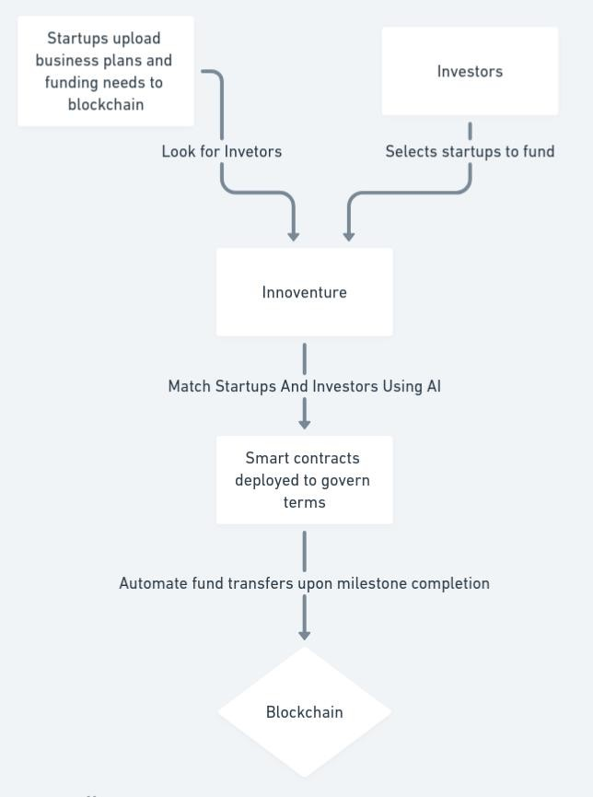

Figure 2.1. Interaction between Startups, Investors, Blockchain, and Smart Contracts

AI in Investor-Startup Matching
The qualitative and business perspective of AI adoption in VC and startups has not received much attention. The most noticeable studies in the past and handful number of researchers have contributed on the technical level, constructing AI algorithms and that aim to boost significance of using AI in VC-backed startup opportunities. There are some platforms also, that made AI enhanced platforms, allowing entrepreneurs to prioritize their efforts effectively.
- Improved Investment Decision: Mishra et al. (2017) suggested a model that looked for- ward to improve VC decision-making by describing a causational map of the investment decision using Bayesian networks.
- Machine Learning based matching: Ross et al. (2021) developed a ML model to predict the upcoming unicorns to invest in, drawing on Crunchbase data and reporting an 89% accuracy rate.
- Enhanced Investor Matching: AI tools like Crunchbase Pro and Affinity use advanced data analytics to match startups with investors who are most likely to be interested in their specific industry and stage of development, improving the efficiency and effectiveness of the fundraising process.
- Continuous Learning and Adaptation: Entrepreneurs must stay informed about the latest developments in AI technology to continually adapt and improve their fundraising strate- gies. Regular usage of AI tool performance helps to ensure business goals and study market dynamics.
- Strategic Advantage in Fundraising: By integrating AI into their fundraising strategies, startups gain a significant strategic advantage, enabling them to navigate the complex investment landscape more effectively and secure funding more efficiently.

AI Models for Matching and Analysis
Matching algorithms serve as the backbone of data-driven processes, facilitating efficient con- nections and improvise between entities within vast datasets. At their core, these algorithms helps to analyze data to identify patterns and similarities, enabling the swift, smooth and accu- rate matching of relevant information.

    - Semantic Matching in Natural Language Processing: In NLP, semantic matching means checking if two sentences have the same or similar meaning by comparing them. These sentences can be a phrase, a paragraph or any part of text. This is especially important in searching engines.
    - Semantic Matching with Transformer-based PLMs: Bi-Encoders use a PLM (a kind of smart language tool) to handle two sentences. Each sentence goes through the PLM one at a time and gets turned into a number list called a vector. Then, the two vectors are compared using math (like cosine-similarity) to find out how similar or different the sentences are.
    - Sentence-BERT: Sentence Embeddings: Sentence-BERT uses of Bi-Encoders, offering an effective approach to generating sentence embeddings. BERT focuses on creating embeddings where similar sentences are positioned close to each other in vector space.
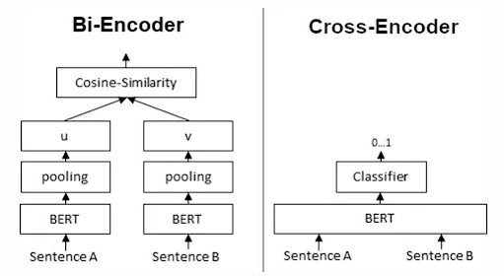
Figure 2.2. Bi-Encoder Architecture for Sentence-BERT

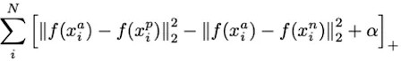
Figure 2.3. Sentence Embedding Equation

    - Psychometric Testing: Psychometric Testing refers to a range of assessments designed to measure an individual’s mental abilities, personality traits, approach, attitudes, and behaviors.
These type of techniques are often used and applied in recruitment and selection processes, personal development, career counselling.

Case Studies: Successful AI-Driven Investment Matches
    - Predictive VC Matchmaking: A biotechnology startup utilized Crunchbase Pro, a com- pany that provides information about business, successfully raise $20 million in Series a funding by targeting investors with a history of supporting biotech innovations.
    - Personalized Pitch Enhancement: VoiceVibes, a mobile health app company secured $15 million by refining their pitch to match investor emotional cues.
    - Efficient Networking: An e-commerce platform specializing in sustainable products stream- lined their investor engagement using HubSpot CRM, which led to a successful funding round.
    - Enhancing Investor Matches Through Sentiment Analysis: Mattermark, a platform helped startups to positively identify investors by using sentiment analysis and getting fruitful results.
    - Streamlining Investor Engagement with Machine Learning: Affinity, a software company identified key investors for a renewable energy startup, leading to a significant investment based on shared values.
    - Diversity Focused Investment: All Raise and Diversity VC, a fintech startup initialized by a diverse team successfully secured a substantial seed round from investors committed to diversity by utilizing network and AI tools.

Summary
This chapter reviews the evolution of investment platforms, highlighting inefficiencies in tra- ditional systems such as high costs, centralized trust, and limited global access. Existing plat- forms like AngelList and Kickstarter have improved connectivity but lack transparency and automation. Blockchain and smart contracts address these issues by offering decentralized, secure, and transparent solutions, automating processes, reducing costs, and enabling global participation. Additionally, AI-powered tools enhance investor-startup matching through pre- dictive analytics, semantic matching, and psychometric testing, significantly improving invest- ment decision-making and fundraising efficiency. Case studies demonstrate the success of these technologies in transforming the investment landscape.

Chapter 3
Requirement Specification & Analysis

Introduction
The project focuses on developing a blockchain-based smart platform to connect innovative ventures, startups, and industries. This chapter outlines the functional and non-functional re- quirements of the platform, the system’s architecture, database schema, and design diagrams that form the foundation for the platform’s development.

Functional Requirements
The table below represents functional requirements of our system, with each requirement as- signed a unique serial number. Most of these requirements are related to core functionality of our system and thus, all are prioritized equally. The status column in the table represents the state of requirement, showing whether it has already been implemented, in consideration or is in progress.
Table 3.1. Functional Requirements

Module | S.No | Functional Requirement | Status
Front-End / UI | 1 | Must be able to register as the Startup, In-  vestor and Admin | Implemented
Front-End / UI | 2 | Must be able to login as above mentioned  roles | Implemented
Front-End / UI | 3 | Dashboard For Admin | Implemented
Front-End / UI | 4 | Dashboard For Investor | Implemented
Front-End / UI | 5 | Dashboard for Startup | Implemented

Module | S.No | Functional Requirement | Status
Blockchain | 6 | Blockchain Integration for smart con-  tracts and transactions | Implemented
Backend/ Model | 7 | AI Match Making Model | Implemented
Backend/ Model/ API | 8 | Analytics and Reports | Implemented
Backend/ Model/ API | 11 | Fine-tuning model | Implemented

Non-Functional Requirements
The following table represents non-functional requirements that do not affect the core function- ality of our application but still need to be ensured for a better user-experience.
Table 3.2. Non-Functional Requirements

S.No | Non-Functional Requirement
1 | The platform should be capable of handling increasing numbers of  users, transactions, and startups as it scales
2 | Secure data encryption, user authentication, and blockchain transaction  validation to protect both user and financial data
3 | Fast response times, especially in matching investors with startups and  processing smart contracts, without compromising security
4 | The application should be active 24 hours
6 | An intuitive and user-friendly interface that makes navigation easy for  both startups and investors

Flow Diagram
This diagram represents a blockchain and AI-based system connecting startups and investors through a centralized platform named InnoVenture. Key points are:
- Profiling:

  - Startups and investors are profiled based on their data
  - Validation ensures authenticity through detailed checks for both parties

- AI Matchmaking:

  - Machine learning models analyze profile data and attributes
  - Matches are determined based on thresholds set by predefined metrics

- DAO Integration:

  - The system uses Decentralized Autonomous Organizations (DAO) for transparency and trust
  - Blockchain secures transactions using smart contracts
  - Equity is tokenized, and an escrow mechanism is implemented for secure fund transfers

- Workflow:

  - Startups submit their profiles → System validates details → Investors view profiles after validation → AI matches investors with relevant startups
  - DAO governance oversees the blockchain layer for tracking and security

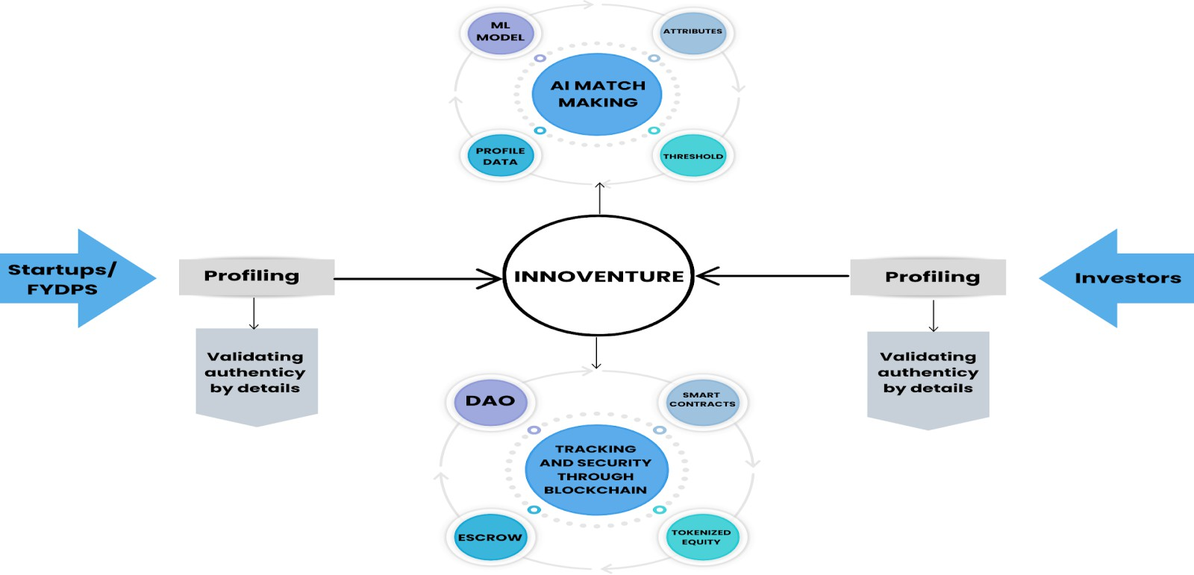

Figure 3.1. Flow Diagram

Technology Stack Used

Front End
      - Programming Languages: JavaScript, TypeScript

      - Front-End Frameworks/Libraries: React

      - CSS Framework: Tailwind CSS

Back End
      - Programming Languages: TypeScript, Python

      - Framework: Nest.js, Flask

      - Database: MongoDB

      - Tools: Swagger, Jupyter Notebook

Use Case Diagram
This diagram represents the interactions between various actors (startups, investors, blockchain, and DAO governance) in the system. Key points:
- Investor Workflow:

  - View available startups and investment opportunities
  - Select projects and make investments
  - Track the progress of their investments

- Startup Workflow:

  - Provide project details and submit financial reports
  - Receive investments from matched investors

- Blockchain Integration:

  - Execute transactions securely
  - Create and manage smart contracts

- DAO Governance:

  - Approve investment decisions
  - Enable transparent voting on opportunities

- AI System:

  - Matches startups with investors
  - Analyzes startups’ viability based on the submitted data

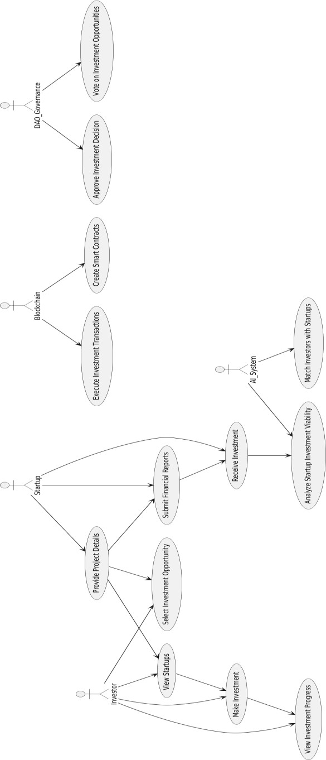
Figure 3.2. Use Case Diagram

ERD of our database system
This diagram appears to represent an Entity-Relationship Model (ERD) for a system involving investors, startups, milestones, investments, and a DAO governance structure. Below is an explanation of its key components:
- Investor:

  - Attributes: id, name, email, profileStatus, preferences, criteria
  - Relationships:
    - Takes part in DAO Governance
    - Monitors Startups
    - Creates Smart Contracts
    - Invests in Startups
- Startup:

  - Attributes: id, name, status, businessPlan, financialDocuments
  - Relationships:
    - Monitored by Investors and Admins
    - Receives Investments
    - Associated with Milestones
- Admin:

  - Attributes: id, name, role, permissions
  - Relationships:
    - Monitors Startups
- Smart Contract:

  - Attributes: id, address, status, terms, escrowAmount
  - Relationships:
    - Created by Investors

    - Associated with Milestones
- Milestone:

  - Attributes: id, description, dueDate, status
  - Relationships:
    - Linked to Smart Contracts and Startups
- Investment:

  - Attributes: id, amount, terms, contractDetails
  - Relationships:
    - Sent to Startups
- DAO Governance:

  - Attributes: id, votes, outcome
  - Relationships:
    - Involves Investors

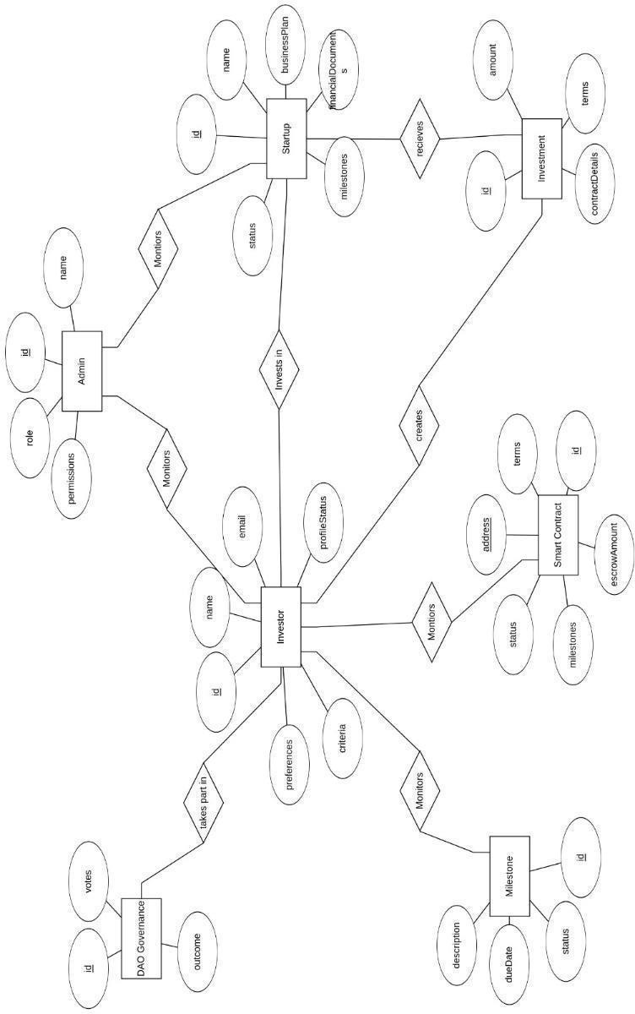
Figure 3.3. ERD Diagram

Activity Diagram
This diagram outlines a detailed architecture for a blockchain-based investment platform. Key points:
- Actors:

  - Includes investors, startups, and admins as primary users

- Modules:

  - Frontend: User interface for interacting with the platform
  - Backend: Handles project management, financial analysis, and data storage
  - Blockchain: Manages transactions, smart contracts, and tokenized equity

- DAO Governance:

  - Integrated voting system for approving or rejecting proposals
  - Tracks voting results and adjusts smart contracts accordingly

- AI Module:

  - Features an investor matching algorithm to connect startups and investors
  - Processes financial data to evaluate project viability

- Process Flow:
  - Users sign up → Submit project or investment details → Validation occurs via algo- rithms → Smart contracts are executed for investments → DAO ensures governance and transparency

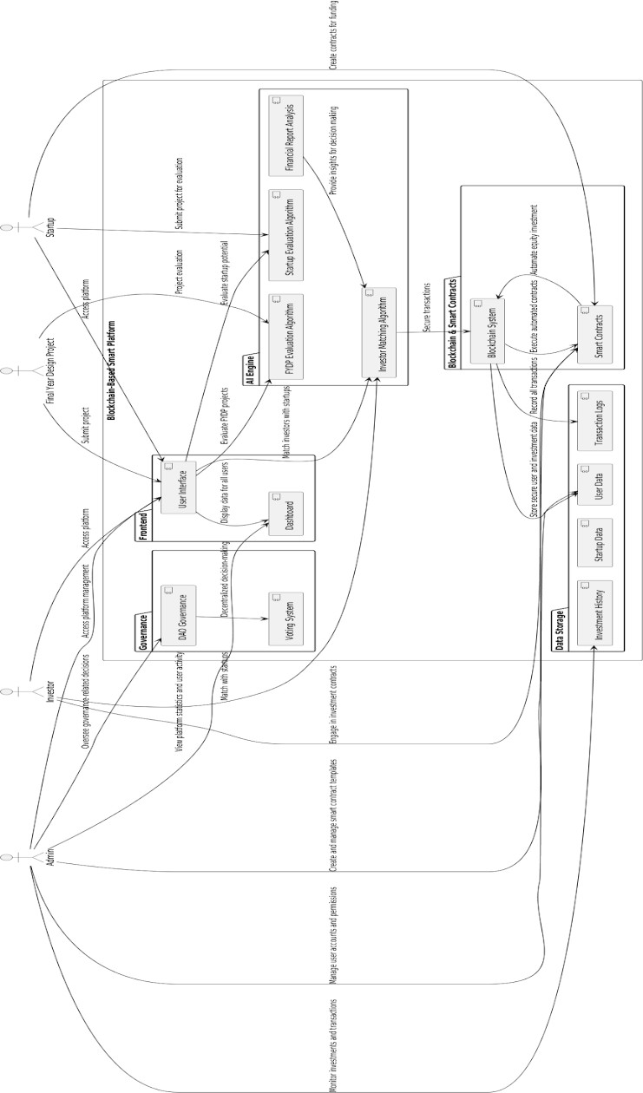
Figure 3.4. Activity Diagram

Chapter Summary
This chapter has outlined the requirement specifications and analyzed the key components nec- essary for building the platform. These include functional and non-functional requirements, use case and activity diagrams, as well as system architecture that ensure security, scalability, and user-friendliness.

Chapter 4
System Design and Implementation

Introduction
In this chapter, we discuss the process of implementing system design and blockchain-based investment platform. We cover important platform features, functionality, architectural design and implementation process for both Frontend and Backend. To ensure the functionality of individual components to ensure that each piece of the system automatically works properly.

Platform Features and Functionalities

Blockchain-Based Investment System
      - Blockchain Integration: Ensures secure, transparent transactions

      - Token Management: Issuing platform-specific tokens for transactions and investment tracking

      - Transaction History: All transactions are recorded on the blockchain for transparency

AI-Powered Matching Algorithm
      - Machine Learning: Uses decision-making algorithms to analyze user data, predict suc- cess probabilities, and match investors to startups

      - Natural Language Processing (NLP): Assists in extracting relevant information from pro- files and proposals to enhance matching

Decentralized Governance (DAO)
      - Voting System: Users can vote on platform governance decisions, ensuring a decentral- ized decision-making process
      - Proposal Management: Proposals submitted by users can be voted on through a secure, transparent system

Smart Contract Automation
      - Equity Distribution: Smart contracts automatically execute equity distribution based on pre-defined conditions
      - Milestone-Based Funding: Funds are released to startups in phases as they achieve mile- stones

Architectural Design
A modular and tiered architectural design was used in the platform’s construction to guarantee scalability, maintainability, and simplicity of integration with new technologies. Each layer is in charge of a distinct set of tasks, and they all cooperate to provide a solid backend and a smooth user experience.

Frontend Layer
The platform’s frontend is built using React.js, which helps create a smooth and interactive user experience. We use Tailwind CSS for styling to keep everything clean, responsive, and consistent across different screen sizes. This makes the interface modern, easy to navigate, and friendly on both desktop and mobile devices.
Key functionalities include:
      - Interactive dashboards for startups and investors

      - Real-time updates using WebSockets for notifications

      - Smooth animations and transitions for better UX

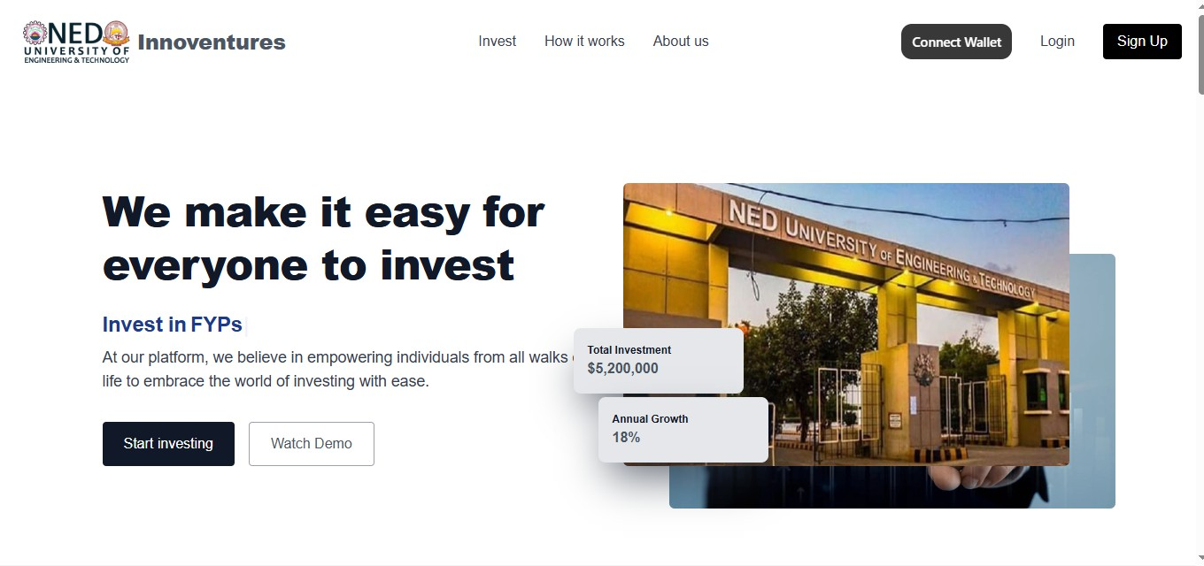
Figure 4.1. Landing Page

Backend Layer

The backend is built with Nest.js, a Node.js framework that’s great for creating fast and scal- able server-side applications. It handles the main logic, processes API requests, and connects smoothly with smart contracts on the blockchain.
Key capabilities include:

      - RESTful API development with OpenAPI (Swagger) documentation

      - Authentication and role-based access control

      - Business logic and investment workflow handling

      - Smart contract event listening and logging

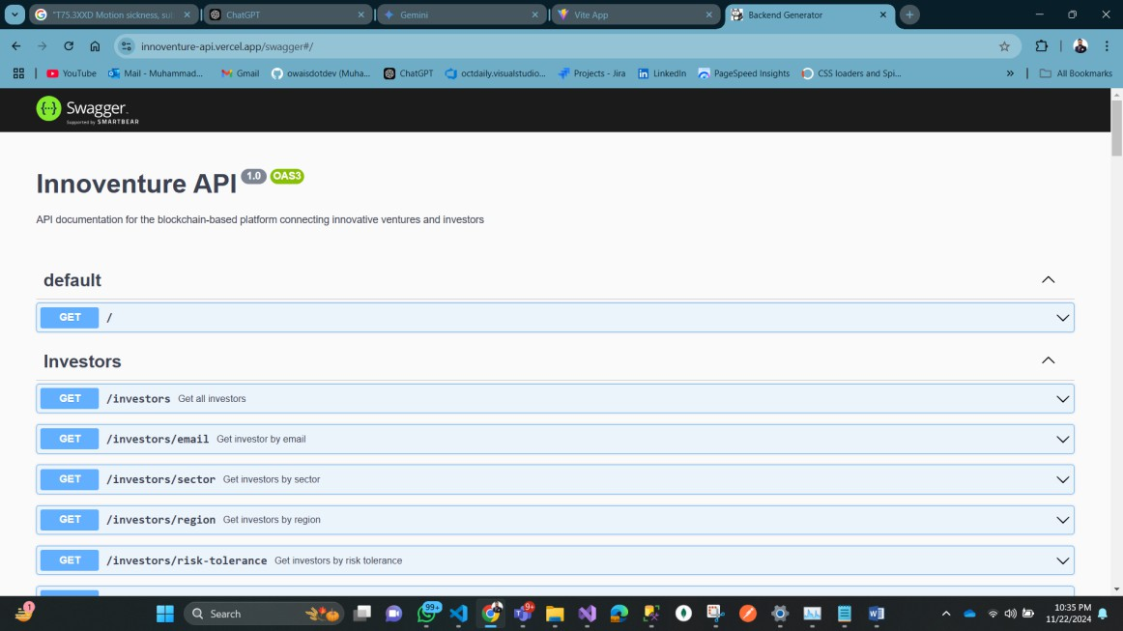
Figure 4.2. Swagger for APIs

Blockchain Layer
The blockchain component is built on the Ethereum network. It ensures immutability, trans- parency, and decentralized execution of investment-related operations through smart contracts. Key roles:
      - Secure equity distribution through automated contracts
      - On-chain milestone-based funding triggers
      - Integration with IPFS for decentralized file storage

AI Layer
Artificial Intelligence is integrated using TensorFlow and PyTorch frameworks. These models power the investor-startup matching system and analyze startup potential and FYDP success probabilities.
Core AI functions:
      - Investor preference clustering using collaborative filtering
      - Natural language processing for profile and pitch analysis

      - Predictive analytics for startup success and ROI estimation

Database Layer

The data layer is implemented using MongoDB, a flexible NoSQL database optimized for handling large volumes of structured and semi-structured data.
Database stores:

      - User profiles and role definitions

      - Startup details, milestones, and equity structures

      - Voting results and governance proposals

      - Smart contract metadata and blockchain logs

Collections are designed with indexing and schema validation to optimize performance and maintain data integrity.

Frontend Design and User Interface (UI/UX)

The frontend is designed using React.js and styled with Tailwind CSS to ensure a modern, clean, and responsive interface. Key features include:

Admin Dashboard

Displaying platform statistics, investors, startups and admin controls to overview all the activi- ties related to the platform.

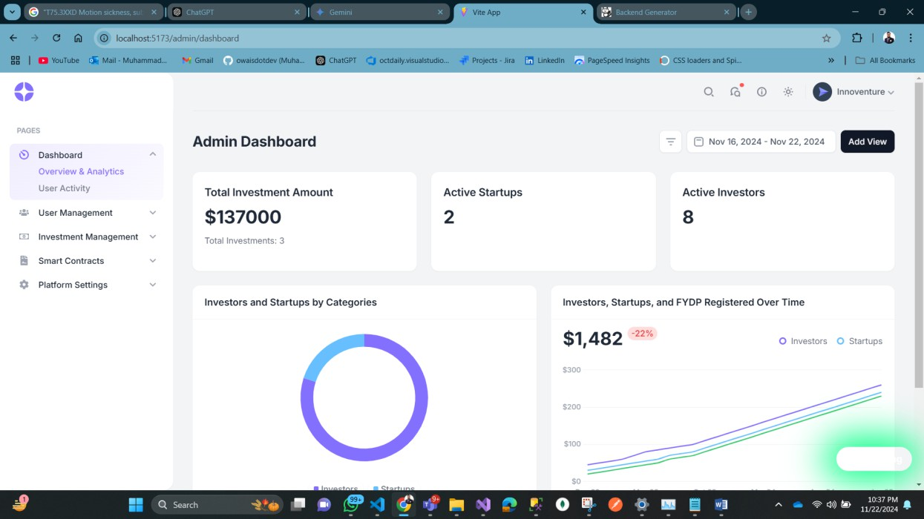
Figure 4.3. Admin Dashboard

Investor Dashboard

Displaying potential investment opportunities, current investments, and transaction history.

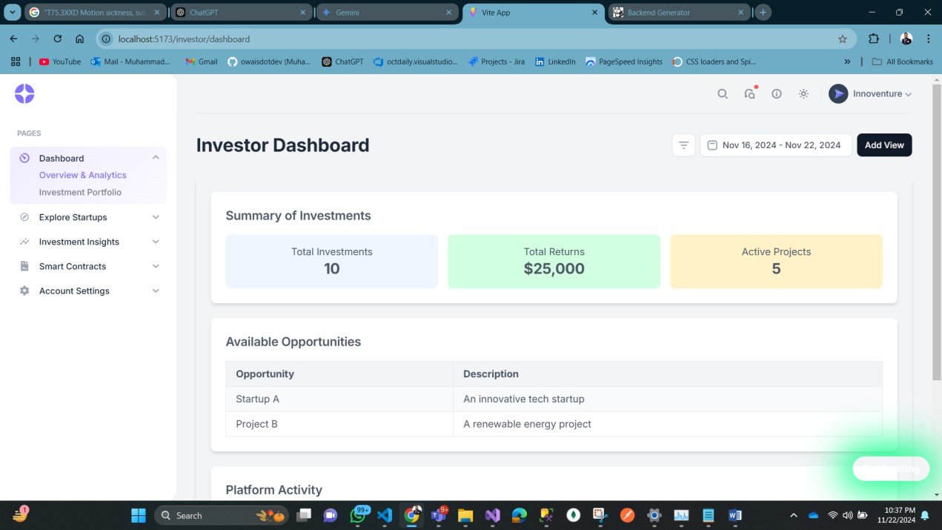
Figure 4.4. Investor Dashboard

Startup Dashboard

Showing funding milestones, financial reports, and progress.

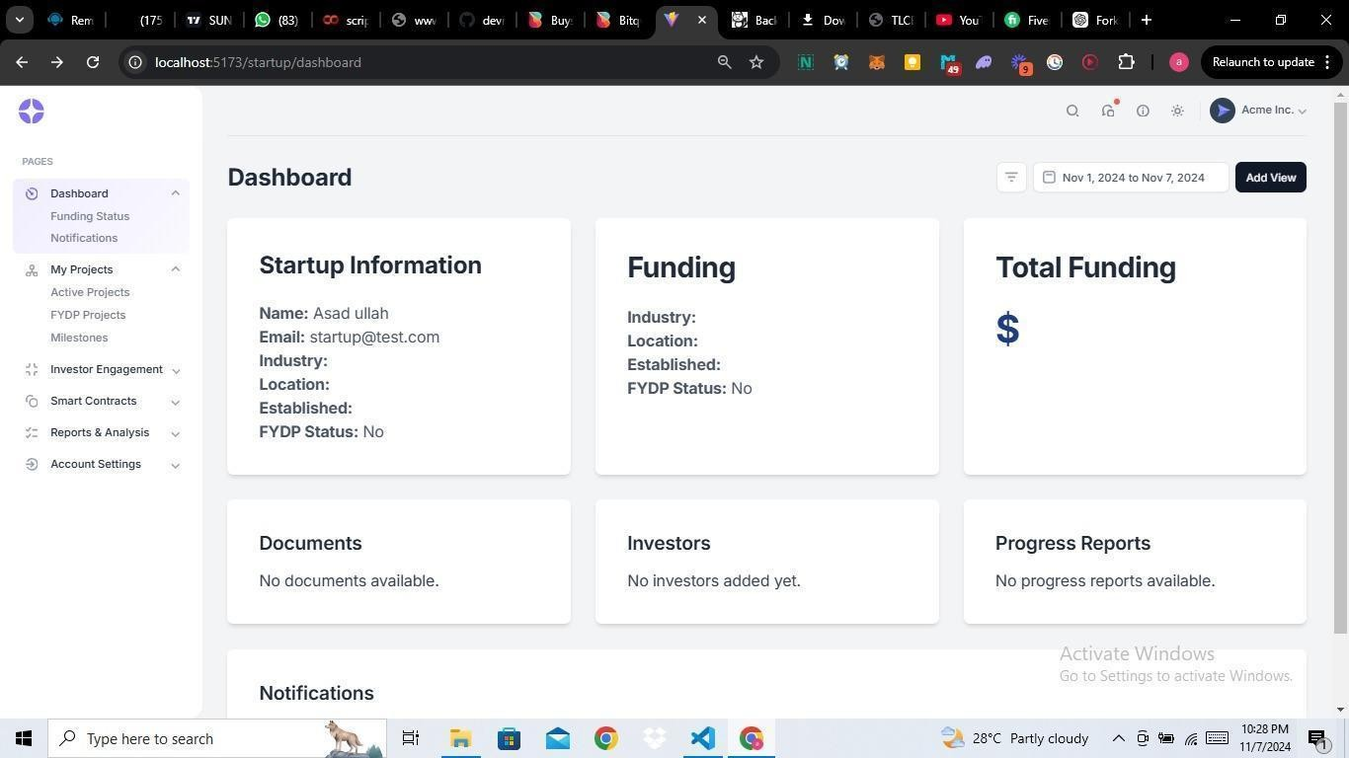
Figure 4.5. Startup Dashboard

Matching System

A user-friendly interface to guide users through the AI-powered investor-startup matching pro- cess.

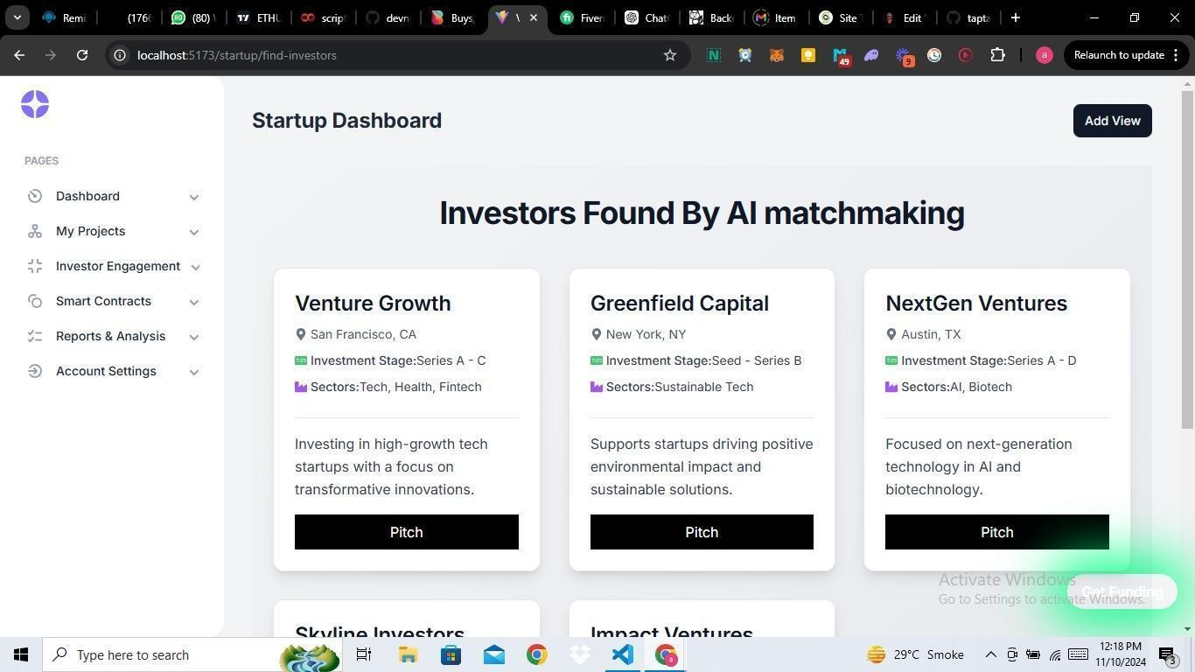
Figure 4.6. Investor matchmaking using AI

Backend Design and Integration

The backend is built with Nest.js and powers the core features of the platform. It provides API endpoints for things like user login and profile management, handling investments and trans- actions, managing smart contracts, running AI-based matching and analytics, and supporting governance voting. All these parts work together to keep the platform running smoothly and efficiently.

Security and Compliance Framework

The platform is designed with strong security in mind. It uses data encryption to protect all user information and financial transactions. Users are to be verified through secure methods like multi-factor authentication and OAuth. Smart contracts are carefully secured to prevent tampering, and everything follows legal and financial regulations to ensure data protection. These measures work together to keep user data safe and financial operations trustworthy.

Chapter Summary
Chapter 4 covered how the platform was designed and built, including its main features, overall structure, and the technologies behind it. The goal is to make the platform secure, transparent, and efficient for both investors and startups. It uses blockchain, AI, and smart contracts to automate tasks and simplify the investment process.

Chapter 5
Testing and Quality Assurance

Introduction
In the field of software development, testing is one of the major steps, even more so for ap- plications that are using blockchain technology and financial transactions together. It not only ensures that each functional element works according to plan, it also confirms that there are no inherent risks present, and that it will perform well under the different loads of use. Each piece of the investment platform was tested one by one and together with various methods of testing. This chapter explains how the issues were handled and resolved and the testing strategy, tools, and methodologies used during the development process.

Testing Strategy and Methodology
A layered and iterative testing approach was used so that quality and maintainability were not compromised. First, each unit was tested as a separate component that was the beginning stage of the process and later, the procedure was moving on to the more complex integration and system-wide testing. In this way, the detection point was moved to the earliest possible stage resulting in identifying the problems when they were small and cheap to eliminate.
Phases of testing included:

- Unit Testing: Checking out single functions and components in isolation.

- Integration Testing: Making sure that different modules and APIs are functioning well together.
- System Testing: Checking the whole platform in a real production environment.

- Performance Testing: Observing the system’s behavior under different load conditions.

- Security Testing: Verifying that the security measures are in place and that there are no potential weaknesses.
- Continuous Testing: The test suites are run automatically by the development and de- ployment pipelines.
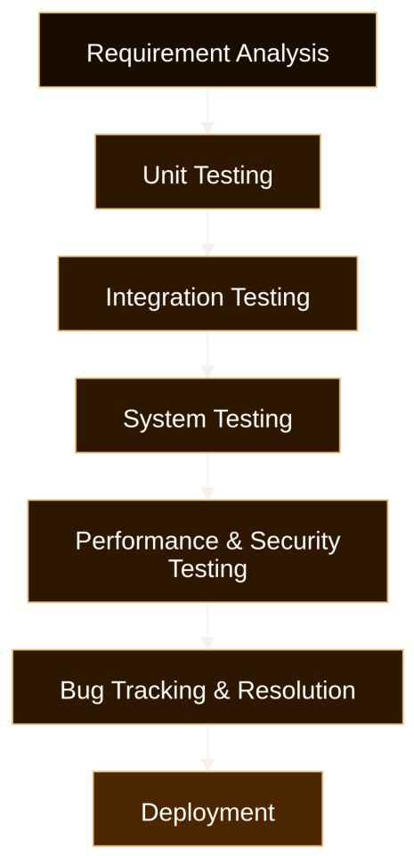
Figure 5.1. Testing Phases

Each phase was accompanied by careful documentation, test reports, and bug tracking to main- tain transparency and quality control.

Unit Testing
Before being incorporated into the system, unit testing makes sure that distinct features, proce- dures, or parts operate as intended.

Frontend Unit Testing
Unit tests were the choice for all these parts of the user interface like input fields, buttons, modals, and dashboards, and the ones constructed using the Jest and React Testing Libraries. The investment forms were in the limelight of the testing phase, where they were completely checked using the input, error, and check controls. For example, the tests developed for the purpose of buttons stayed the same while important fields were not properly filled, and also for receiving the wrong investment amounts were not stopped - no such events happened.

Backend Unit Testing
The backend in NestJS was tested with the help of Jest and Supertest. The developers of this JavaScript framework decided to use services as a good example of AdminDashboardService and tested each of them by creating mock data for the input. This way they verified the correct aggregation of finished and pending investments. Another aspect of unit tests was to ensure that controllers could handle edge cases such as missing parameters and unauthorized access and return the desired results. Thus, registration of investors, startup profiles and deposit creation were tested separately.

Smart Contract Unit Testing
Smart contracts, written in Solidity, were tested using Truffle and Hardhat. Each function of the contract such as updateInvestmentStatus(), checkMilestones(), and transferFunds() was checked with these tools regarding the appropriate access control, handling of invalid trans- actions, and right behavior. Furthermore, the positive events were tracked with the help of test cases, including halted conditions in case of failed milestone approvals or incorrect fund transfers.

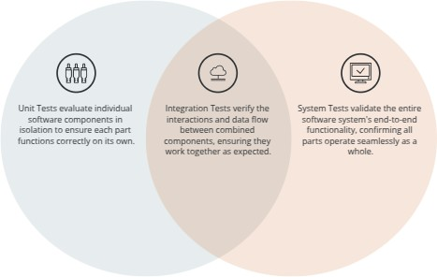

Figure 5.2. Correlation Of unit, integration and system testing

Integration Testing
Integration testing made sure that various system components functioned well together after individual modules passed their unit tests.

Backend API Integration
For the purpose of checking whether API points could reach the database and the client, writers at Difitechs resorted to Postman and Supertest in their testing. For a specific example, Postman and Supertest were used to create API requests and test if valid and invalid data were correctly handled through a simulated process of the investor deposit.

Smart Contract Integration
Hardhat and Ethers.js were used to test the integration of contracts performing different trans- actions. The procedure was as follows, first, the verifiers had to identify and sign off on the milestones, and later, the startup would get the funds after the smart contracts released them.

Besides that, investors, who were assisted by the backend, had their investment balances and statuses checked in the system to see if everything was correct.

System Testing
System testing, being the verifying of execution at an integrated level, was carried out on the corresponding processes of the application. The testing, done in a production-like environment, has confirmed the end-to-end processes of the system.

Functional Testing
A range of end-to-end workflows, such as investor registration, deposit via a corresponding means, startup submission of a milestone report, and administrator release, was executed and tested on by using Cypress, Postman, and Hardhat. The checks were carried out to help the flow of all updates accurately through the frontend, blockchain, and backend.

End-to-End (E2E) Testing
Cypress and Playwright were used to recreate the roadmaps (User Journeys) of typical members who were given the assignment of managing an investment, selecting a suitable investment, conducting a payment, keeping track of historical data, and checking the dashboard. We did not overlook edge cases; we went even further to allow scenarios of investing without enough funds and sending false data.

Cross-Browser Testing
The tests were implemented through BrowserStack and Selenium which run on multiple browsers such as Chrome, Firefox, Edge, and Safari with the sole purpose of ensuring that the UI is con- sistent.

Responsiveness Testing
The development of the platform was done with React which was used to ensure the platform was responsive to different screen sizes as the user opens the application on a mobile device or

desktop. The implementation of the service with the help of network drivers aims to guarantee a secure and safe connection to the Internet at any position within the short range of networks and spaces without the requirement of a cable.

Performance Testing
The whole platform was subjected to performance testing using Jmeter to confirm the following characteristics of the system: capability, reliability, fault tolerance, etc. This method was the final proof of the ability of the system to work.

Load Testing
The system’s performance while dealing with large loads was watched by conducting numer- ous stress tests in which many users signed up, made investments, and approved the planned activities all at once using tools like Apache JMeter, K6, and Locust. Metrics such as errors, turnaround times, and the demand for server CPU/memory were taken into account to recog- nize the places where the system became slower and slower.

Stress Testing
The system was provoked to work extremely hard by simulating up to a higher user threshold than expected so that its behavior was inspected in such a case. This was good for the purpose of finding out mistakes and testing the system recovery.
The findings demonstrated that smart contracts handled transactions without going over al- lowable gas limits, and the backend could manage more than 1,000 concurrent requests with consistent performance.

Security Testing
Security proved to be the major concern because of the infrastructure of the platform and the fact it is a blockchain-enabled one.

Smart Contract Security Testing

Smart contracts were examined for flaws such as reentrancy attacks, integer overflows and underflows, and inappropriate access controls using MythX and Slither. Since fund transfers and milestone verification were delicate areas that could be exploited, special attention was paid to them.

Web Application Security Testing

The integrated platform was used as a testbed for those commonly found web vulnerabilities such as SQL Injection, Cross-Site Scripting (XSS), and broken access controls. For blockchain, it was more about confidentiality so the unauthorized transactions on blockchain were also checked.
The vulnerabilities found were patched, and retesting was conducted. They had been split up by severity of the impact.

Bug Tracking and Issue Resolution

GitHub Issues was used to meticulously track bugs and issues during the development cycle. Developers were tasked with fixing each bug, which was categorized according to its type and severity (Critical, Major, Minor). To rank issues and evaluate progress, weekly review meetings were conducted. This well-structured process made it possible to quickly solve problems and ensured that no important problems were left unfixed prior to deployment.

Figure 5.3. bug reporting process

Testing Tools Used

Category Tools Used
Frontend Unit Testing Jest, React Testing Library Frontend E2E Testing Cypress, Playwright Backend Unit Testing Jest, Supertest
Backend Integration Postman, Supertest
Smart Contract Testing Hardhat, Truffle, MythX, Slither, Ethers.js, Remix Performance Testing Apache JMeter, K6, Locust
Security Testing MythX, Slither, OWASP ZAP, Ethlint Cross-Browser Testing BrowserStack, Selenium Responsiveness Testing Chrome DevTools, Lighthouse CI/CD Testing Jenkins, GitHub Actions

Test Results and Evaluation
Once all the planned tests were completed, the following observations were made:

- Over 95% of the tests carried out (both integration and unit tests) were successful.

- End-to-end testing demonstrated that the most complex processes performed without interruption across different browsers and on various devices.
- Several medium and low-severity bugs did surface from security testing, and all of them were resolved before the software went live.
- The software was found to have stable behavior even when taking the server resources to their maximum with up to 1,000 live users, thus performance testing was be considered a success.
- GitHub Actions’ continuous testing strategy achieved two goals: first, it enabled the association to detect problems early, and secondly, it became the instrument of checking if the pushed code was incongruent with the existing function.
The live deployment readiness of the platform was confirmed by the good results.

Chapter Summary
This chapter presented the systematic way that was followed to assess and warrant quality of the investment platform. The continuous automated testing combined in CI/CD pipelines with unit, integration, system, performance, and security testing produced a stable, secure, and efficient platform. The early detection and resolution of problems by modern tools and transparent pro- cedures were the enablement of a reliable and smooth experience for both, startups, investors, and administrators.

Chapter 6
Results and Discussion

Overview of Results
The blockchain- and AI-driven platform developed in this project has successfully fulfilled its objectives of democratizing startup investment, improving transparency, and providing a secure, scalable solution for matchmaking between investors and startups. Through intensive system testing and stakeholder feedback, the platform proved effective in integrating smart contracts for milestone-based funding and an AI recommendation engine for investor-startup pairing. Key achievements include robust performance under load, accurate matchmaking, and secure transaction management.

Comparison with Existing Systems
In evaluating InnoVenture against traditional platforms like AngelList and Kickstarter, it be- comes clear that our platform represents a Web3-native evolution that outperforms legacy Web2 systems in multiple dimensions—particularly in automation, trust, intelligence, and decentral- ization.

Web2 vs Web3 Architecture

Feature | AngelList | Kickstarter | InnoVenture
AI Recommenda-  tion | None (Manual Cura-  tion) | None (Open List-  ings) | Advanced AI Match-  making
Matching Logic | Investor Searches | Creators List  Projects | Semantic Embedding  & Compatibility Scores

Feature | AngelList | Kickstarter | InnoVenture
AI Models Used | N/A | N/A | Sentence-BERT,  Word2Vec
Matching Accu-  racy | Manual & Subjec-  tive | Crowd-Driven | Embedding Similarity  (Semantic Matching)
Data Inputs | Tags, Keywords | Campaign Descrip- tions | Full-Text NLP Embed- dings of Investor Crite- ria & Startup Descrip-  tions
Table 6.1. Comparison of AI-Powered Matching vs Traditional Filtering

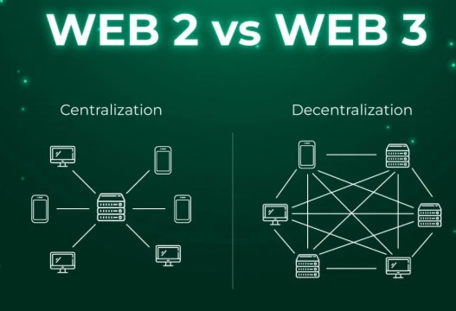
Figure 6.1. Web2 vs Web3 Architecture

InnoVenture introduces a Web3-native experience, powered by Ethereum smart contracts and decentralized governance (DAO). This contrasts with AngelList and Kickstarter’s Web2-based centralized frameworks, where control, data, and rules remain with the platform itself.

AI-Powered Matching vs Traditional Filtering

Feature | AngelList | Kickstarter | InnoVenture
AI Recommenda-  tion | None (Manual Cura-  tion) | None (Open List-  ings) | Advanced AI Match-  making
Matching Logic | Investor Searches | Creators List  Projects | Semantic Embedding  & Compatibility Scores
AI Models Used | N/A | N/A | Sentence-BERT,  Word2Vec
Matching Accu-  racy | Manual & Subjec-  tive | Crowd-Driven | Embedding Similarity  (Semantic Matching)
Data Inputs | Tags, Keywords | Campaign Descrip- tions | Full-Text NLP Embed- dings of Investor Crite- ria & Startup Descrip-  tions
Table 6.2. Comparison of AI-Powered Matching vs Traditional Filtering

InnoVenture leverages transformer-based sentence embeddings to evaluate and match investor profiles with startup business models and goals. This allows for:
      - Deep semantic understanding
      - Matching based on meaning, not just keywords
      - Personalized AI-curated recommendations

Performance Evaluation

AI/NLP-Based Investor-Startup Matching Evaluation
The AI layer in InnoVenture leverages transformer-based sentence embedding models to eval- uate semantic similarity between startup proposals and investor preferences. We utilize all- MiniLM-L6-v2, a high-performing, resource-efficient model developed by SentenceTransform- ers.

Feature | AngelList | Kickstarter | InnoVenture
Trust  Cost Efficient Global Reach AI-powered Security  Legal Framework Automation  Transparency | ✓  ✓  ✓  ✓ | ✓  ✓ | ✓  ✓  ✓  ✓  ✓  ✓  ✓  ✓
Table 6.3. Feature Matrix comparing AngelList, Kickstarter, and InnoVenture

Parameter | Details
Model Architecture | all-MiniLM-L6-v2 (Bi-Encoder, Transformer-based)
Parameter Count | ∼22.7 million
Layers | 6 Transformer layers
Hidden Size | 384
Embedding Dimension | 384-dimensional dense vector
Inference Speed | Highly optimized for real-time use on commodity hardware
Use Case Fit | Ideal for semantic search and text matching at scale
Table 6.4. Model Overview

Challenges and Limitations
Despite technical success, several real-world challenges remain:
- Adoption Barrier: Building a trustworthy and engaging platform requires traction and user confidence. The value of the platform increases with more users, making early- stage adoption critical. Without a committed user base, the system’s network effects are limited.
- Market Penetration: While the system is robust, attracting a community of serious in- vestors and innovative startups is vital. For expansion, strategic outreach and partnerships are necessary to draw users who recognize the value proposition and trust the system’s integrity.
- Perceived Risk in Blockchain: Although blockchain ensures transparency, many tradi- tional users remain skeptical of its implications and complexity. A simplified UX and user education will be key to reducing friction.

- AI Dependence on Data Volume: The AI system’s precision can improve with more data. In the initial phases, the limited dataset restricts model training and hinders full potential.

User Feedback
Initial pilot testing with a small group of users, including investors and academic participants, yielded promising feedback:
- Investors appreciated the automatic risk scoring and milestone-based funding structure.

- Startups valued the clarity and structure brought by smart contracts and the visibility to multiple funding sources.
- Suggestions included: mobile accessibility, easier onboarding, and the inclusion of domain- specific AI filters for sector-specific matchmaking (e.g., FinTech, HealthTech).
This feedback has informed roadmap features, including multilingual support, mobile app de- velopment, and enhanced user analytics dashboards.

Chapter Summary
This chapter presented the key results and findings derived from the development, deployment, and evaluation of the InnoVenture platform. Through systematic comparison with traditional Web2-based platforms like AngelList and Kickstarter, the superiority of our decentralized, AI- driven system becomes evident.
Key outcomes include:

- Comparison with Existing Systems: InnoVenture sets itself apart by integrating blockchain- based smart contracts for secure, milestone-based funding, and leveraging AI-powered semantic matching, where other platforms rely on static, manual workflows. A detailed comparison illustrated how InnoVenture surpasses in trust, automation, security, and de- centralization.
- Web2 vs Web3 Differentiation: Traditional platforms operate under centralized Web2 paradigms, where data and control rest with the platform. In contrast, InnoVenture ex-

emplifies Web3 principles—user ownership, on-chain governance, decentralized oper- ations, and tamper-proof records—making it inherently more transparent, secure, and participatory.
- Performance Evaluation:

  - Blockchain Layer: The serverless architecture ensures infinite horizontal scalabil- ity, public transparency, and fault tolerance. There are no API bottlenecks or back- end dependencies, and all operations are verifiable on-chain.
  - AI Layer: The system uses all-MiniLM-L6-v2, a 22.7M parameter transformer model optimized for sentence embeddings. It enables precise semantic matching by converting user inputs into dense vector representations and comparing them us- ing cosine similarity. The model delivered high accuracy, fast inference (¡2.1s), and scalable performance using FAISS vector search.
Overall, this chapter affirms that InnoVenture is more than a technological upgrade—it is a transformative step toward a transparent, decentralized, and intelligent investment ecosystem. It addresses the longstanding inefficiencies in investor-startup interaction and unlocks real po- tential for FYDPs, startups, and small-scale investors globally.

Chapter 7
Future Enhancements

Introduction
The current version of the platform has built a strong and feature-rich ecosystem for decen- tralized investment. It includes key modules like investor-startup matchmaking, IPFS-based storage, voting-driven governance, and Ethereum smart contracts, serving as both a proof of concept and a minimum viable product (MVP) for wider applications.
Still, platforms built on blockchain must keep evolving to tackle ongoing challenges around security, scalability, compliance, and user expectations.
This chapter outlines the platform’s future roadmap, focusing on key improvements—from enhancing the system’s architecture to aligning with regulations, expanding decentralized gov- ernance, and making the platform more inclusive for users.

Planned Technical Improvements

Enhanced Platform Security
Security is key to building trust, especially on a platform that handles sensitive data like intel- lectual property and financial transactions. To help prevent data breaches, impersonation, and tampering, the following improvements are planned:
      - Multi-Factor Authentication (MFA): Users authenticate using two or more factors—such as password and biometric verification—to mitigate risks of unauthorized access. Tools like Google Authenticator or biometric face recognition may be used for web and mobile apps.
      - End-to-End Encryption (E2EE): All messages and sensitive user data (e.g., wallet ad- dresses, startup pitch decks, and legal documents) are encrypted at both the transmission

and storage levels using AES-256 or equivalent cryptographic protocols.
      - AI-Based Intrusion Detection Systems (IDS): Leveraging machine learning algorithms, the platform detects anomalous behaviors such as sudden access pattern changes, SQL injection attempts, or wallet drain simulations. Alerts are generated and access blocked proactively.
Justification: With rising cyber-attacks on blockchain startups, these upgrades offer both pre- ventive and reactive mechanisms, establishing long-term credibility and legal defensibility.

AI-Driven Startup and FYDP Evaluation
As the number of submissions increases, manual screening becomes a bottleneck. AI enables objective, scalable evaluations of startups and Final Year Design Projects (FYDPs) through:
      - Predictive Modeling: Training models using historical data to estimate the likelihood of success, ROI, and investment security. Metrics like burn rate, market traction, team strength, and patent status feeds the model.
      - Skill & Team Analysis: Natural language processing (NLP) assess the resumes, technical reports, and pitch content to determine team experience, innovation value, and technical feasibility.
      - Market Intelligence Integration: APIs like Google Trends, Crunchbase, or open-source economic datasets helps identify alignment between proposed solutions and emerging market gaps.
      - Real-World Use Case: A student-led FYDP focused on blockchain-based voting may be rated highly if the model identifies regulatory demand and feasibility with smart contract integration.

Feature Expansion and Scalability

Smart Contract Enhancements
Current smart contracts are static and manually governed. The upgraded version is to be made modular and reactive:

      - Milestone-Based Equity Distribution: Funds or equity are released only when specific milestones (e.g., prototype submission, revenue generation) are validated on-chain.

      - Dynamic Investment Terms: Smart contracts supports real-time negotiation, adapting terms based on external market conditions, risk scores, or governance votes.

      - On-Chain Compliance Audits: Regulatory and institutional guidelines (like NEDUET’s IP policies) are to be embedded as conditional clauses within smart contracts, triggering flags if violated.

Feature | Current State | Future Upgrade
Equity Distribution  Investor Governance Legal/Policy Compliance | Manual  Limited Voting Off-chain Review | Milestone-Triggered  DAO-Based Contract Updates On-chain Auto Audit
Table 7.1. Smart Contract Enhancement Comparison

DAO-Based Governance
The existing governance module will evolve into a full Decentralized Autonomous Organiza- tion (DAO), granting more control to stakeholders:

      - Proposal System: Any verified user (investor or project lead) can create proposals for platform improvements, feature inclusion, or funding distribution.

      - Voting and Tokenization: Stakeholders receive governance tokens (non-monetary) to vote based on contributions or platform engagement.

      - Community-Powered Upgrades: Proposals with quorum votes will be merged after re- view, and a changelog will be published via a decentralized Git-like system.

Example: If a majority votes to support a new startup category like ”ClimateTech”, the database and UI are dynamically updated through the governance protocol.

Cross-Platform and Multi-Chain Integration
The long-term vision includes universal compatibility and decentralized inclusivity:

      - Mobile App Development: A React Native-based mobile version will be developed with QR-based wallet login, push notifications, and offline data caching.
      - Multi-Chain Wallet Support: Integration with wallets such as MetaMask, Trust Wallet, and WalletConnect across Ethereum, BNB Chain, and Polygon.
      - Live Sync and Versioning: Users can access the same profile, voting status, and proposal drafts across devices with real-time sync.
Technical Highlight: IPFS CIDs (Content Identifiers) will be versioned and cached for mobile retrieval without high latency or gas costs.

Wider Applications and Compliance Considerations

Regulatory Compliance and IP Policy
Aligning with the IP policy of NEDUET is vital for platform legitimacy. Compliance features include:
      - Automated IP Agreement Acceptance: All users must digitally sign the NED IP policy terms before project upload.
      - Dynamic Clause Embedding in Contracts: Smart contracts will embed references to in- stitutional guidelines, making violation enforceable on-chain.
      - Audit Reports for IP Violations: An AI-aided mechanism will flag copied projects or content mismatches using NLP plagiarism models.

Expansion to Broader Use Cases
While currently focused on FYDPs and startups, the architecture is scalable for:

      - Research Grant Distribution: Universities or donors can post funding calls, while projects compete via proposal voting and milestone submission.

      - Public Infrastructure Investments: A community can vote and fund local infrastructure (e.g., solar panels, sanitation) using transparent smart contracts.
      - Educational Crowdfunding: Students from underprivileged backgrounds can submit ver- ified applications, voted on and funded through DAO allocations.
Example: A donor interested in female education can fund 10 students directly through a milestone-tracked smart contract system.

Localization and Inclusion
To accommodate diverse users from rural areas and varying backgrounds:

      - Multi-Language Support: Interfaces will support Urdu, Sindhi, Pashto, and English with automatic font scaling for readability.
      - Regional Legal Compliance: Local tax, fundraising, and IP regulations will be integrated based on user location or institution.
      - Inclusive UI/UX: UX will be optimized for low-latency networks and non-tech-savvy users, with simplified navigation and accessibility options (e.g., screen reader compati- bility).

Chapter Summary
This chapter laid out a clear plan for the next stage of the platform’s development. It focuses on strengthening the core systems, adding cross-platform support, simplifying compliance, and introducing smarter, decentralized tools to help the platform grow in a sustainable way. Every update is aimed at building trust, making the platform easier to use, and meeting regulatory and institutional standards.
In short, the goal is much bigger than just connecting investors and startups—it’s about creating a powerful, decentralized space that supports innovation and investment for students, investors, and institutions alike.

Chapter 8
Conclusion

Summary of Contributions
This project provides an end-to-end equity-investment platform that integrates blockchain trans- parency, AI-powered matching, and automated governance into a single experience. We devel- oped a set of Solidity smart contracts that track equity splits, disburse milestone-based fund- ing, and vest automatically— removing manual reconciliation and significantly minimizing the risk of fraud. A collaborative-content-filtering hybrid AI layer suggests investor-startup matchups, and a React/Tailwind UI presents these capabilities via an easy-to-use multi-panel dashboard. A Node/Express gateway binds frontend, blockchain, and NoSQL store, offering a fluid, low-latency process that leads users from profile setup to finalized investment without the inevitable paperwork roadblocks.
Apart from the technical artefacts, the platform generates valuable channels for early stage funding by putting under represented university ventures on the same platform as traditional startups. Final Year Design Projects (FYDPs) which might otherwise be stuck in academic archives can now present prototypes, get formalized feedback, and raise capital. A DAO mech- anism built in encourages token owning stakeholders to participate in voting for listing pro- cesses, rules of dispute resolution, and future developments, thus integrating openness and shared ownership to the core of the system. Collectively, these contributions offer a copycat playbook for closing the gap between academic innovation and investable markets, creating avenues for retail investors and first-time founders alike.

Lessons Learned
Technically, we learned that security architecture prioritization ahead of feature growth is nec- essary. Initial prototypes emphasized user experience refinement, but follow-up audits revealed

issues from inadequate input sanitisation and vaguely restricted contract permissions. Imple- menting a ”security first” backlog—consisting of threat modeling, static analysis, checks, and multi signature ownership—prevented critical vulnerabilities from making it to production. We also discovered the boundaries of out of the box metrics of evaluation when training rec- ommender systems on sparse investment data, which led to a move towards domain-specific measures that are more representative of decision quality for startups and investors alike.

Managerially, the project identified the importance of ongoing stakeholder alignment and agile governance. Early workshops showed a disconnect between investor aspirations for liquid- ity and founder hopes for mentorship and protection of intellectual property. Triaging meet- ings on a regular basis reconciled these priorities and led to the introduction of dynamic term sheet templates balancing equity stakes, advisory credits, and IP provisions. Distributed agile ceremonies—daily stand-ups, sprint reviews, and open issue tracking—fostered responsibility across a far-flung team. Ultimately, these practices highlight that technological innovation only thrives when complemented by formal communication and a willingness to rebalance scope as new learnings emerge.

Project Impact and Final Reflections
The platform’s wider meaning is that it has the potential to democratize early-stage venture cap- ital and rationalize the process of taking an idea to market. By reducing monetary barriers and incorporating compliance regulations into tamper-proof smart contracts, the system encourages smaller investors who are otherwise kept out by high barriers to entry. Startups appreciate im- mutable cap table records and milestone-triggered disbursements, allowing founders to avoid administrative burden and invest more time in product development. FYDP teams, commonly inventive but underfunded, receive increased visibility and a concrete route to commercialisa- tion.

If we look Ahead, a few directions can take this further. Layer 2 blockchain integrations would make transactional costs lower, making micro investments all the more attractive. Raising the AI engine to take qualitative considerations into account—like social impact alignment or founder team harmony—would improve match precision and bring in mission motivated cap- ital. Formal partnerships with regulatory sandboxes would speed up compliance certification

and build confidence for risk adverse stakeholders. Overall, the project not only fulfils its ini- tial goals but creates a scalable basis for a transparent, inclusive, and data driven investment environment. Through harmonization of blockchain security, AI intelligence, and user cen- tric design, the platform shows how careful technology convergence can materialize promising concepts into market ready realities.

Bibliography

- Nakamoto, S. (2008). Bitcoin: A Peer-to-Peer Electronic Cash System.
- Peters, G. W., & Panayi, E. (2016). Understanding Modern Banking Ledgers through Blockchain Technologies. Journal of Banking & Finance.
- Chen, W., & Xu, X. (2017). Blockchain Applications in Crowdfunding. IEEE Transac- tions on Blockchain.
- AngelList. (n.d.). How It Works. Retrieved from https://www.angellist.com.
- Kickstarter. (n.d.). About Us. Retrieved from https://www.kickstarter.com.
- Zheng, Z., Xie, S., & Dai, H. (2017). Blockchain Challenges and Opportunities: A Survey. International Journal of Blockchain Applications.
- Antonopoulos, A. M. (2014). Mastering Bitcoin: Unlocking Digital Cryptocurrencies.
- Swan, M. (2015). Blockchain: Blueprint for a New Economy. O’Reilly Media.
- Szabo, N. (1997). The Idea of Smart Contracts. Retrieved from https://www.smartcontracts.com.
- Tapscott, D., & Tapscott, A. (2016). Blockchain Revolution. Penguin Random House.
- Bessen, J., Impink, S., Seamans, R., & Reichensperger, L. (2018). The business of AI startups. SSRN Electronic Journal. doi:10.2139/ssrn.3293275
- Executive Office of the President, National Science and Technology Council Commit- tee on Technology. (2016). Preparing for the Future of Artificial Intelligence, National Science and Technology Council. U.S. Government.
- Ivashchenko, T., Chornodid, I., & Ivashchenko, A. (2020, September 11). The Business Assistant Service is one of the Promising Areas for the Adoption of AI Technologies in the Enterprise

- Allen, J. F. (1998). AI growing up: The changes and opportunities. AI Magazine, 19(4)
Retrieved on -May 15,2022 from https://doi.org/10.1609/aimag.v19i4.1422

- Kaplan, S., & Lerner, J. (2016). Venture capital data: Opportunities and challenges. National Bureau of Economic Research Working Paper Series, http://www.nber.org/papers/w22500.
- Bonaccorso, G. (2017). Machine learning algorithms Packt Publishing.

- Davalas, A. (2020, November 30). Use of Big Data and AI Tools to Evaluate and Assist Startups.
- Corsello, A., & Santangelo, A. (2023). May Artificial Intelligence Influence Future Pae- diatric Research?
- The Case of ChatGPT. Children (Basel, Switzerland), 10(4), 757. doi:10.3390/children10040757 PMID:37190006

